## New Serial Number to Device – Manual Method

There might be certain instances where the user may need to manually change/add a new EVK serial number to the Talaria TWO (T2) device.

The manually update Talaria TWO device’s serial number, follow the subsequent steps:

* 1. Ensure the device connected is detected under COM Port as shown in Figure 25.

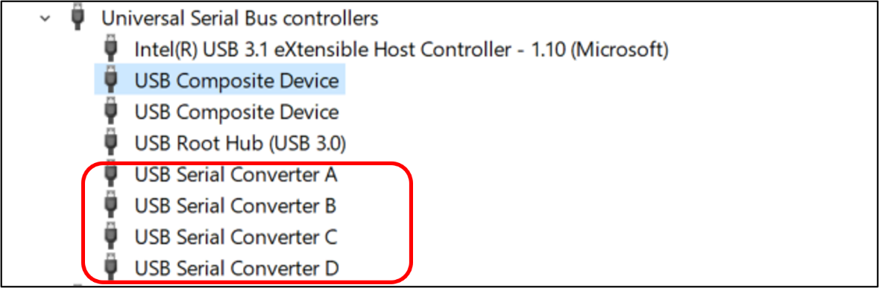

Figure 25: Device Manager – Composite Device

* 1. In case the device is not detected under COM Port, follow the instruction available in section: Update Driver from libusK Driver to COM Port to change the driver to USB Composite Device.
  2. Once the device is recognized under COM Port, install FT_Prog software with the help of [Utilities - FTDI (ftdichip.com)](https://ftdichip.com/utilities/) to change the FTDI device property as required.
  3. Open the FT_Prog software and click on Scan & Parse button to detect the COM devices. FT_Prog software shows the identified devices in tree with device properties, as shown in Figure 26.

Figure 26: FT_Prog - Device detected

* 1. To update the serial number, click on USB String Descriptor. Add the new serial number in the Serial Number field and change the product description as InnoPhase T2 Evaluation Board, as shown in Figure 27.

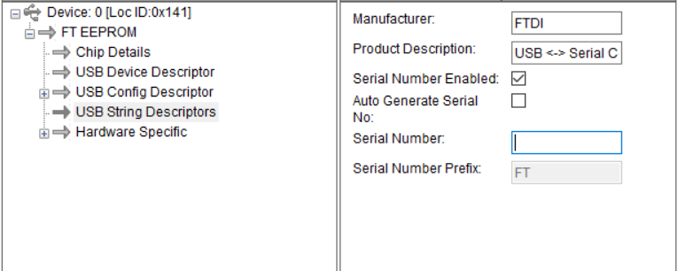

Figure 27: FT_Prog - Update Serial Number

* 1. To upload the changes to the device, right click on FT EEPROM and click on Program Device, as shown in Figure 28.

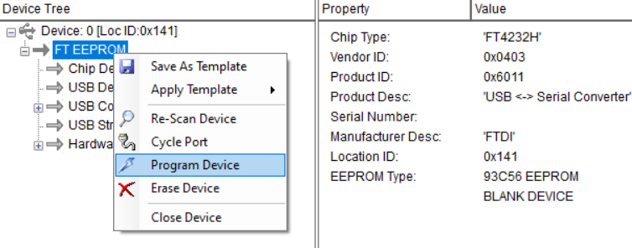

Figure 28: FT_Prog - Program Device

* 1. The device will now be updated with the new serial number as shown in Figure 29.

Figure 29: FT_Prog - Updated Serial Number

* 1. In case the new serial number is not updated in Device Manager, unplug and re-plug the device to refresh the connection.